Saturation, Atmospheric Stability and Smog City Lab
Instructions:
For the lab you will read the pdf and use the word document to return your typed answers.
Saturation and Atmospheric Stability Lab Answers
- A: m = __________g/kg (1-points)
B: m = __________g/kg

- A: m = __________g/kg (1-points)
B: m = __________g/kg

- For questions 3 & 4 move the three dots at the bottom (3-points).
- 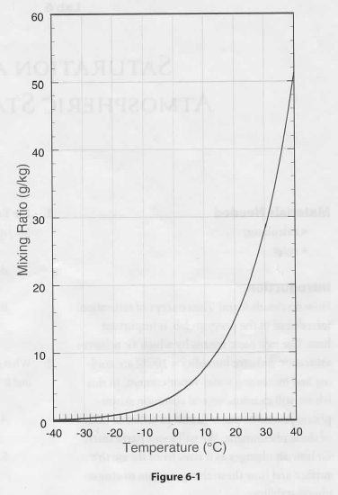

- _________ (1-point)

- _________ (1-point)

- _________ (1-point)

- _________ (1-point)

- _________________________________________________________________________________________________________________________________________________________________________________________________________________________(1-point)

- (2-points)
Height (m) | Temperature C
1000
900
800
700
600
500
400
300
200
100 | 35 C

- (2-points)
Parcel A Temperature C | Height km
 | 5.0
 | 4.5
 | 4.0
 | 3.5
 | 3.0
 | 2.5
 | 2.0
 | 1.5
 | 1.0
 | 0.5
28 C | Surface

- (2-points)
Parcel B Temperature C | Height km
 | 5.0
 | 4.5
 | 4.0
 | 3.5
 | 3.0
 | 2.5
 | 2.0
 | 1.5
 | 1.0
 | 0.5
10 C | Surface

- _________________________________________________________________________________________________________________________________________________________________________________________________________________________(1-point)

- (2-points)
Height m | Temperature C | Dew-Point Temperature C
2000
1500
1000
500
Surface | 30 C | 14 C

- A: _______
B: _______ (1-points)

- _________________________________________________________________________________________________________________________________________________________________________________________________________________________(1-point)

- Hint: when convective cumulus clouds are present assume T = 10 C and dew-point T = 2 C
__________ (1-point)

- (2-points) Windward side
Height m | Temperature C | Dew-Point Temperature C
2500
2000
1500
1000
500
Sea level | 25 C | 13 C
(2-points) Leeward side
Height m | Temperature C | Dew-Point Temperature C
2500 | Same as Windward above | Same as Windward above
2000
1000
Sea level

- Hint: where did the temperature and dew-point temperature coincide on the windward side
________m (1-point)

- _________________________________________________________________________________________________________________________________________________________________________________________________________________________(1-point)

- _________________________________________________________________________________________________________________________________________________________________________________________________________________________(1-point)

Review Questions (2-point):
How is saturation achieved to form most clouds?
__________________________________________________________________________________________________________________________________________________________________________________________________________________________________________

What is the difference between a stable and an unstable atmosphere? Which of these two conditions favor vertical cloud development and why? __________________________________________________________________________________________________________________________________________________________________________________________________________________________________________

CALCULATIONS:

